Ship Deck Implementation

The Costa Concordia has 14 decks which are all different from each other. They are connected by stairs and elevators in different configurations and they full fill different purposes. There are decks for entertainment, eating, shopping, sport and so on.
Due to the big differences of each deck, it is enormous time consuming to implement all these decks with all details in a model. So it is necessary to simplify the decks in a reasonable manner.
Further the picture source is not perfect in size and data type so there is a manual conversion needed.
In this chapter it is shown what assumptions were made and with which conversion techniques the decks were implemented into the model.

- Conversion

Firs of all the decks have to match each other in pixel size and position to allow a flawless connection of the decks. So the size of some decks has to be adjusted and the stair overlay has to be matched as good as possible.
Secondly doors, numbers, names and symbols are removed to have one connected surface without unreal obstacles.

Now that the surfaces are clean and connected, the colours have to be replaced by predefined colours of the code. Violet for spawn of agents, black for walls, red for upstairs, blue for downstairs and different green type for each rescue boat.

In the picture .... a small portion of a deck with stairs, rooms, doors and elevators is shown before and after conversion. In the converted picture is a blue block included for the stairs, which conversion will just be explained in the next part.

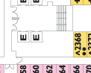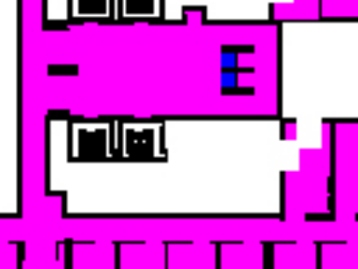

In most of the cases stairs from one to another floor are designed in a spiral way to minimize the consumed space. That leads to a problem by implementing the stairs into the model. It is not possible to make a clean transition from one floor to another without using some tricks.

[2] In the work "Modeling Situations of Evacuation in a Multi-level Building", which is the base of this project, are special additional floors to overcome the mentioned problem. These additional floors which represent the stairs, are a fine method to create an infinite amount of floors and connections without any trouble. But it needs that additional floor for each connection.

While the agents on the ship march only in the direction of the rescue floor the connection can be simplified. So there is a new technique used to get rid of these additional floors.

In the picture.... a spiraling stair connection between floor 01 and floor 02 is shown as example. The arrows in light blue are used to clarify the technique.
The agents arrive from the left on floor 11 and go into the direction of the arrow until they reach the blue box. There they are skipped down on the floor 10 and try to go to the blue box again. So they have to go around to be skipped down again on floor 09 and go around in the other direction. That continues until they reach floor 04 which is the floor with the rescue boats.

With that technique no additional floors are needed and we get very close to the real spiralling stairs. For the ship in that project this is sufficient, because the modelling fault will be in a lower degree than the one of other assumptions.

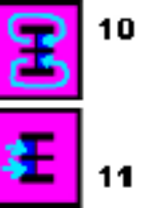

- Similarisation and Reduction

The most important floor for the simulation is of course floor 04 because it holds all the rescue boats as seen on the floor picture .... . There, all agents have to pass and it is reasonable to have it very detailed. Floor 05 and 03 are the ones just above and beyond and will also have a non neglect able influence on the agents movement.

The further we move the less important the deck configuration gets, because it is assumed that the stairs will be the bottleneck. As long as the stair setup corresponds good to the reality, the further decks can differ more.
So it is decided to convert deck 02, 03, 04 and 05 in detail and make a copy with adjusted stairs for each other floor. Floor 02 is used for the copy because it gets the closest to the floor 01, 06 and 07 and is by that still a good approximation.

Floor 08 until 14 differ more from floor 02 but as long as they are far away from floor 04 it wont have a big influence. These last floors are also smaller than floor 02 and therefore the amount of floors is reduced to only 11 with approximately the same area as the original 14 floors.

